SPRING SECURITY ARCHITECTURE

→ Spring Security is a framework in the Spring ecosystem that helps secure your Java/Spring applications.
→ It mainly does two things:

1) Authentication
2) Authorization

and also provides protections like CSRF, password encoding, and integrates easily with JWT, OAuth2, and other protocols."

1. Authentication ("Who are you?")

->Authentication is the process of verifying a user's identity.
->It ensures that the person or system trying to access a resource is who they claim to be.

👉 Example: When you log in to a website with your username and password, the system checks if your credentials match those in the database.

2. Authorization ("What are you allowed to do?")

->Authorization determines what actions a user is permitted to perform after authentication.
->It controls access to resources based on roles or permissions .
->It is implemented using:
Role-based access control (RBAC) (e.g., Admin, User, Guest)
Access control lists (ACL)
Token-based permissions (JWT, OAuth)
👉 Example: After logging in to a system, an admin might have access to user management, but a regular user can only view their profile.

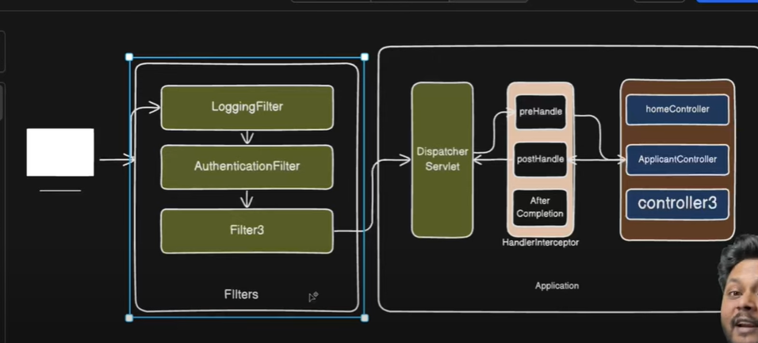
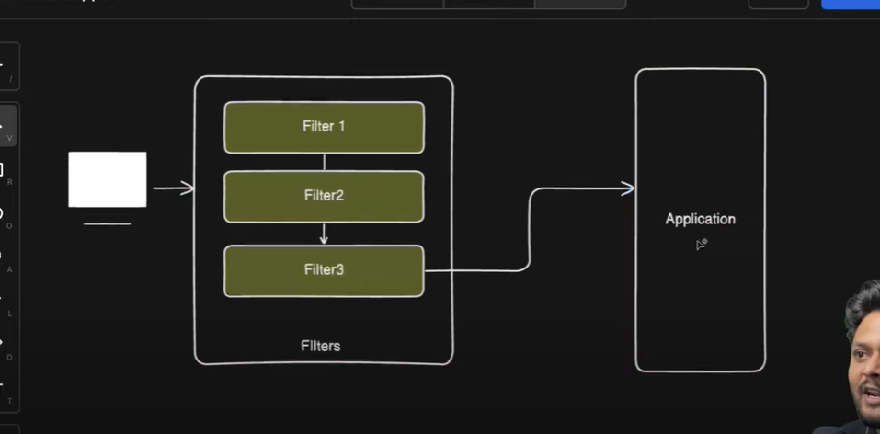

🔹 Diagram Meaning
- Request (User → Browser/App → Server ku oru HTTP request).
- Filters (Filter1 → Filter2 → Filter3 … sequential-a process pannu).
- Application (finally Spring Boot controller/service ku reach aagum).

🔹 Step by Step Explanation

1. Request varuthu
- User one HTTP request send panra (example: /login, /products, /book-ticket).
- Ithu server ku vandha udane, direct controller ku pogathu.
- First ah Filter chain la pogum.

2. Filters Work (Servlet Filter or Spring Filter)
- Filters are like security guards or checkpoints.
- Example filters:
  - Filter1 → Authentication check (token valid ah nu paapum).
  - Filter2 → Authorization (user role: ADMIN ah, FARMER ah nu paapum).
  - Filter3 → Logging / Request modification (headers add panna, trace id, etc.).
👉 Important: Filters sequential-a execute aagum → Filter1 → Filter2 → Filter3.
👉 If any filter reject panniduchuna, request application ku pogathu (direct error/response send pannum).

3. Application (Spring Boot Controller/Service)
- Filters pass aana request → DispatcherServlet ku send pannum.
- DispatcherServlet decide pannu:
  - /user/** → UserController
  - /owner/** → OwnerController
  - /admin/** → AdminController
- App logic run pannum (DB fetch, business logic, response prepare).

4. Response Return
- Application response create pannidum (JSON/HTML).
- Response back Filters ku thirupi pogum (reverse order: Filter3 → Filter2 → Filter1).
- Finally client ku return aagum.

DelegatingFilterProxy
Request vandha udane → servlet container handle pannum.
- Servlet lifecycle concept la → container filter chain create pannum.
- Andha filter chain’la oru special filter irukum → DelegatingFilterProxy.
- DelegatingFilterProxy → actual ah enna filter nu know pannathu illa, it just delegates (anuppidum).
- Athu request ah Spring IoC container la irukkura springSecurityFilterChain bean ku kudukkum.
- Ithu kitta irundhu thaan → Spring Security filters run aagum (Authentication, Authorization, CSRF, etc.).
👉 So simple separation:
- Before DelegatingFilterProxy → pure servlet lifecycle.
- After DelegatingFilterProxy → springSecurityFilterChain → pure Spring Security lifecycle.
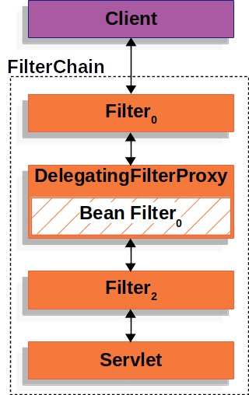

DelegatingFilterProxy (Simple meaning
- Initially → Every request goes to Servlet container.
- Servlet container la, as per Servlet lifecycle, it creates a Filter chain.
- But we need to register Spring Security filter chain (which is actually a Spring bean).
- Problem → Servlet container lifecycle ≠ Spring container lifecycle (rendu separate).
- Solution → DelegatingFilterProxy acts like a bridge:
  - Servlet container la normal filter madhiri register aagum.
  - But internally, it delegates the request to Spring IoC container la irukkura springSecurityFilterChain bean ku.

DelegatingFilterProxy = Dummy filter in servlet container that passes requests to the real Spring Bean filter later.

public void doFilter(request, response, chain) {
// Find the real Spring Bean filter
Filter delegate = getSpringBean("Filter0");

// Pass the work to that bean
delegate.doFilter(request, response, chain);
}
_

FILTER CAHIN PROXY

FilterChainProxy = Spring Security oda main filter for Servlet requests.
- Every request that comes from DelegatingFilterProxy, it delegates to the appropriate SecurityFilterChain.
- SecurityFilterChain contains all the security filters (authentication, authorization, etc.) for that URL.
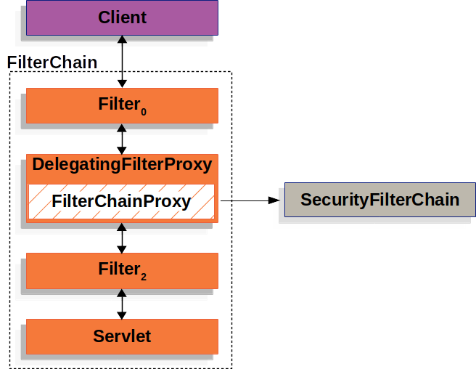
.

advantages of FilterChainProxy :
- Central starting point for all Spring Security filters.
- Clears SecurityContext to avoid memory leaks.
- Applies HttpFirewall to protect against attacks.

SECURITY FILTER CHAIN
* A combination (list) of security filters that Spring Security runs in a specific order for incoming requests.
- IT Decides which filters should run for a request.
- Each filter = Spring Bean, registered with FilterChainProxy.
- Only first matching chain runs.
- A chain can have 0 or more filters.
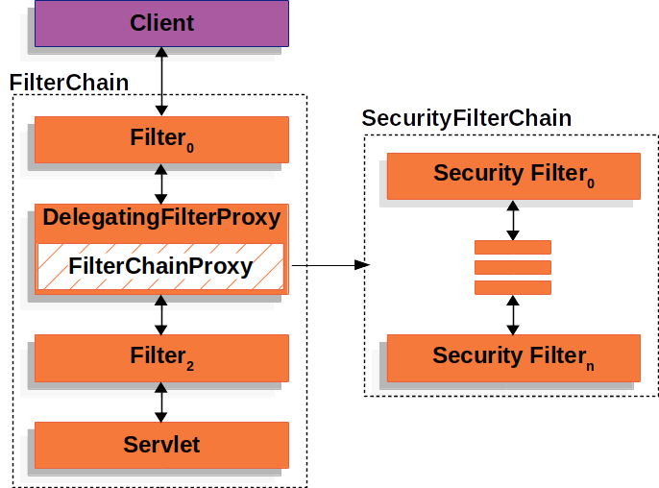
.

FilterChainProxy & SecurityFilterChain (Thanglish)
- FilterChainProxy → decides which SecurityFilterChain runs for a request.
- Only the first matching chain is invoked.
Examples:
- /api/messages/ → matches /api/** → SecurityFilterChain0 runs (3 filters).
- /messages/ → does not match /api/** → SecurityFilterChainn runs (4 filters).

SecurityFilterChain
- Definition: Combination (list) of security filters run in a specific order.
- Purpose: Decides which filters should run for a request.
- Each filter = Spring Bean, registered with FilterChainProxy.
- Only the first matching chain runs.
- A chain can have 0 or more filters.
- Each chain can be unique and configured separately.

Flow:
Request → FilterChainProxy → first matching SecurityFilterChain → filters run → Controller

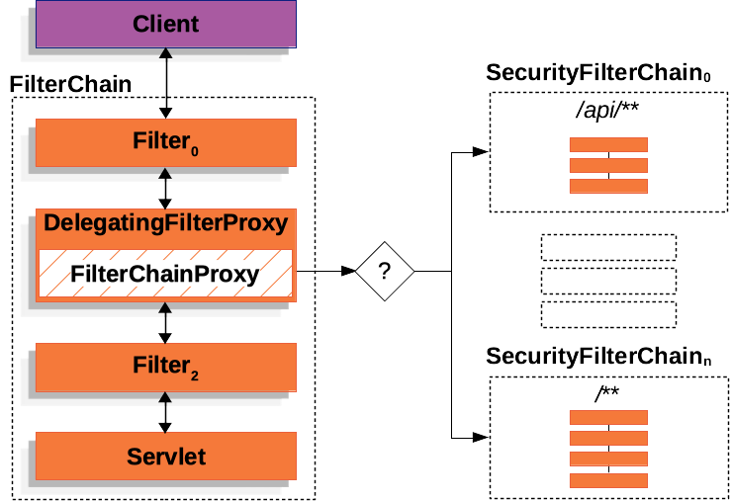
.

Security Filter
Security Filters are added to FilterChainProxy using SecurityFilterChain API.
- Filters can do many things: authentication, authorization, exploit protection, etc.
- Filters run in a specific order to make sure they execute at the right time.
- Example: Authentication filter runs before Authorization filter.
- Normally, you don’t need to know the exact order of Spring Security filters.
- If needed, you can check the FilterOrderRegistration code to see the order.
filterChain() creates a SecurityFilterChain containing multiple Security Filters:
@Configuration
@EnableWebSecurity
public class SecurityConfig {
@Bean
public SecurityFilterChain filterChain(HttpSecurity http) throws Exception {
http
.csrf(Customizer.withDefaults()) // Adds CsrfFilter
.httpBasic(Customizer.withDefaults()) // Adds BasicAuthenticationFilter
.formLogin(Customizer.withDefaults()) // Adds UsernamePasswordAuthenticationFilter
.authorizeHttpRequests(authorize -> authorize
.anyRequest().authenticated() // Adds AuthorizationFilter
);

return http.build(); // Returns a SecurityFilterChain
}
}

Explanation
- filterChain() method → returns a SecurityFilterChain.
- SecurityFilterChain → contains multiple Security Filters:
  - CsrfFilter
  - BasicAuthenticationFilter
  - UsernamePasswordAuthenticationFilter
  - AuthorizationFilter
- FilterChainProxy → later calls this SecurityFilterChain when a request matches.
Thanglish summary:
filterChain() → creates SecurityFilterChain → SecurityFilterChain has multiple filters → FilterChainProxy runs them for matching requests.
________________________________________________________________________________
Spring Security dependency add pannitu oru basic Spring Boot app run panna, default-a Spring Security use panra filters:
- SecurityContextPersistenceFilter – request-ku SecurityContext load & save pannum.
- UsernamePasswordAuthenticationFilter – default form login handle pannum (/login POST).
- BasicAuthenticationFilter – HTTP Basic Auth support pannum (if needed).
- ExceptionTranslationFilter – auth errors 401/403-ku handle pannum.
- FilterSecurityInterceptor – URL access permissions check pannum.
- AnonymousAuthenticationFilter – user login illa na anonymous user provide pannum.
- LogoutFilter – /logout requests handle pannum.
💡 Simple-a: just adding dependency → auto default login page, random password, and above filters are active.

Authentuication Provider
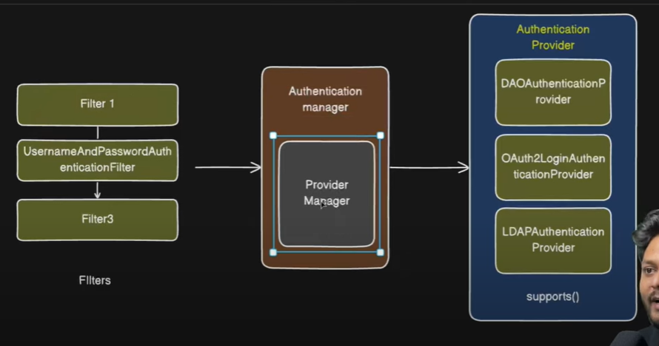
.

🔥 Spring Security – Detailed Authentication Explanation

🟡 ① Filter (First Entry Point in Spring Security)
- Spring Security la filter chain irukum (many filters).
- Login request vandha udane, UsernamePasswordAuthenticationFilter trigger aagum.
- This filter reads username and password from the HTTP request (form / JSON).
- Next → it creates an object called UsernamePasswordAuthenticationToken
(this object implements Authentication => but not authenticated yet).
- Then it calls:
authenticationManager.authenticate(authenticationToken)
🔔 Important: Filter never authenticates, it just collects credentials & forwards.

🟡 ② AuthenticationManager (Central Coordinator)
- Interface with only one method → authenticate(Authentication auth)
- Real implementation: ProviderManager
- It has a List<AuthenticationProvider>
- Responsibility = delegate
→ “Which provider can handle this token?”
→ “Ok, give it to that provider and ask it to authenticate”

🟡 ③ AuthenticationProvider (Actual Authentication Logic)
- Every provider knows HOW to authenticate a particular token.
- It checks:
public boolean supports(Class<?> tokenType)
→ If the incoming token is supported by this provider
- Then it calls:
public Authentication authenticate(Authentication authentication)
→ Here it performs actual validation (DB / LDAP / OAuth2 / etc.)
🟢 Example provider → DaoAuthenticationProvider
- Supports → UsernamePasswordAuthenticationToken
- Calls → userDetailsService.loadUserByUsername(username)
- Gets UserDetails
- Compares raw password with stored password using PasswordEncoder.matches(...)
- If correct → returns a new Authentication object → authenticated = true & with GrantedAuthorities

🟡 ④ UserDetailsService & UserDetails
Interface | Role
UserDetailsService | Loads user from database (by username)
UserDetails | Holds details of that user (username, password, roles...)
👉 Spring uses this to perform the validation and to build successful Authentication object

🟡 ⑤ SecurityContext + SecurityContextHolder
- After success, the returned Authentication object is stored in the SecurityContext
- SecurityContext is saved in ThreadLocal using:
SecurityContextHolder.getContext().setAuthentication(authentication)
- From now onwards, application can know “who is logged in”.
Quick summary
1) Filter → reads username/password
2) Create AuthenticationToken
3) AuthenticationManager (ProviderManager) receives token
4) Chooses AuthenticationProvider based on supports()
5) Provider authenticates using UserDetailsService + PasswordEncoder
6) On success --> returns authenticated Authentication
7) Stored in SecurityContext via SecurityContextHolder
8) AuthenticationSuccessHandler executed

my note

few have some one filter – but whivh filter map to one authentication provider
we use authentication maanger ->Provider Mangaer it helps to find which filter is match to which iterate all and chechk which is support and deligate the request.

USER DEATIL SERVICE
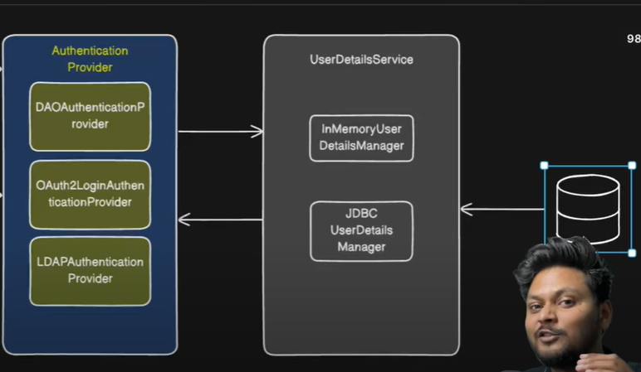
.

📝 UserDetailsService – Detailed Notes

🔹 Definition
- Interface used by Spring Security to load user information during authentication.
- Method:
UserDetails loadUserByUsername(String username)
- Returns a UserDetails object
(contains → username, password, roles, flags like accountNonLocked etc.)

🔹 Why it is used?
- AuthenticationProvider (ex: DaoAuthenticationProvider) does not fetch users directly.
- It calls UserDetailsService → to get user information from memory or DB.
- After that, AuthenticationProvider uses this information to authenticate.

🔹 Built-in Implementations
Implementation | Description | Use case | Source of user data
InMemoryUserDetailsManager | Stores user details in application memory | Demos / Testing | Hardcoded in Java code
JdbcUserDetailsManager | Loads user details using JDBC | Real applications | Database (users and authorities tables)

✅ InMemoryUserDetailsManager
- Users defined manually in code.
- Example:
UserDetails user = User.withUsername("aravind")
.password("{noop}1234")
.roles("USER")
.build();

return new InMemoryUserDetailsManager(user);
- loadUserByUsername() → checks the in-memory list and returns matching UserDetails.

✅ JdbcUserDetailsManager
- Reads user data from database using JDBC.
- Requires a DataSource.
return new JdbcUserDetailsManager(dataSource);
- loadUserByUsername() → executes SQL:
  - select username,password,enabled from users where username=?
  - select authority from authorities where username=?
- Then builds UserDetails from DB result.

🔁 Relation with AuthenticationProvider
→ AuthenticationProvider receives AuthenticationToken
→ Calls userDetailsService.loadUserByUsername(username)
→ InMemoryUserDetailsManager / JdbcUserDetailsManager returns UserDetails
→ AuthenticationProvider continues the authentication process
📌 So UserDetailsService is like a “data provider” for AuthenticationProvider.

_____________________________________________________________________________

der – Final Summary Notes
🔹 Purpose
- Spring Security component used to hash (encode) passwords.
- Ensures that raw passwords are never stored or compared directly.

🔹 Main Methods
Method | Description
encode(rawPassword) | Converts raw password to hashed password
matches(rawPassword, encodedPassword) | Checks raw vs hashed password (returns boolean)

🔹 Common Implementations
Implementation | Description
BCryptPasswordEncoder | Strong hashing (recommended)
NoOpPasswordEncoder | No hashing (plain text) → ❌ not secure

🔹 Usage in Spring Boot
@Bean
public PasswordEncoder passwordEncoder() {
return new BCryptPasswordEncoder();
}
- During registration → encode() is used
- During login → matches() is called by DaoAuthenticationProvider

🔹 Automatic Integration
Situation | Result
PasswordEncoder bean present | DaoAuthenticationProvider automatically uses it
Not provided | Authentication fails / NoOp used (not secure)

✅ Conclusion
PasswordEncoder is a mandatory component for safe authentication.
It encodes passwords and is automatically used by Spring Security when declared as a bean.
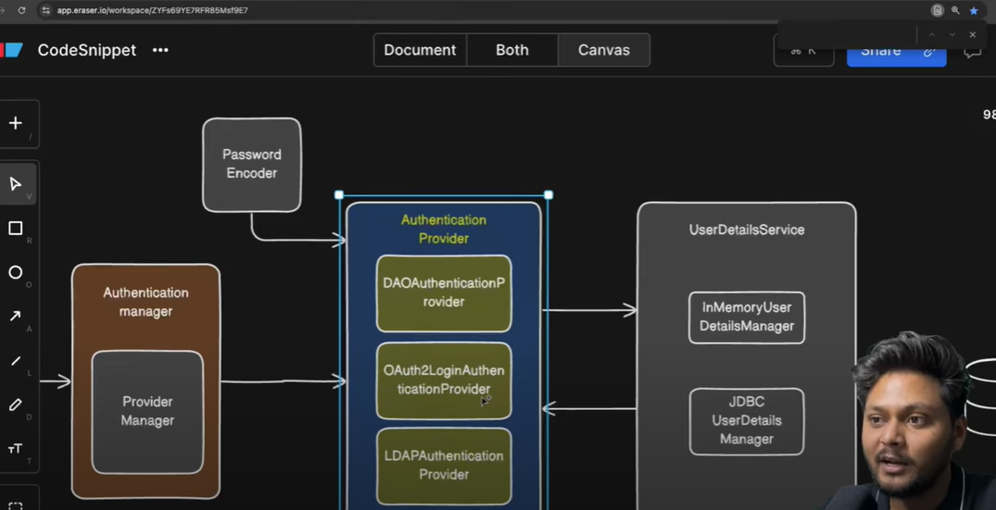
FLOW DIAGRAM.
UsernamePasswordAuthenticationFilter
↓
AuthenticationManager (ProviderManager)
↓
DaoAuthenticationProvider
→ calls userDetailsService.loadUserByUsername(username)
→ InMemoryUserDetailsManager OR JdbcUserDetailsManager
→ returns UserDetails (includes encoded password)
→ DaoAuthenticationProvider calls PasswordEncoder.matches(raw, encoded)
→ if true → authentication success

Security CONTEXT
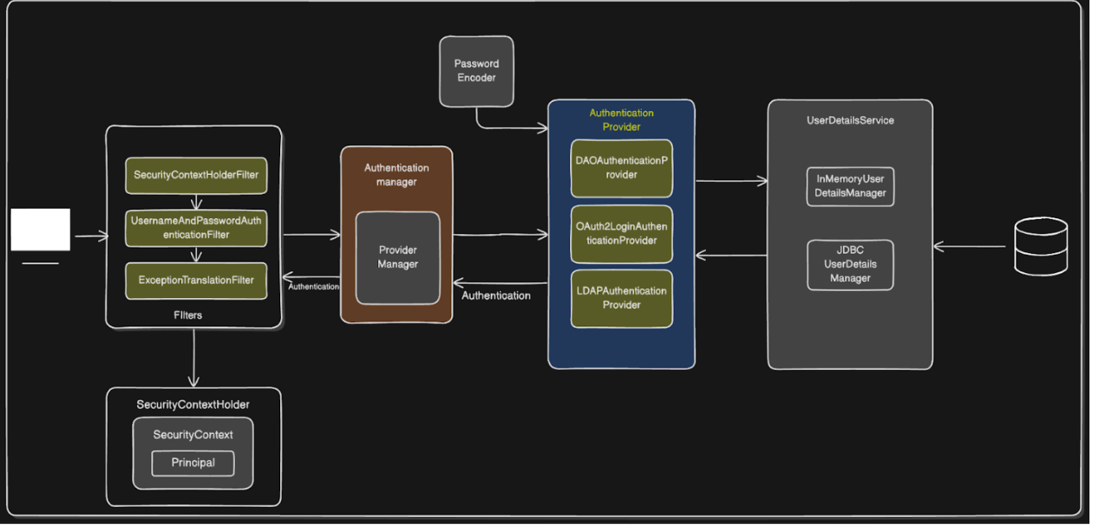

SecurityContext – Neat Notes
🔹 What is SecurityContext?
- A Spring Security object that stores the Authentication information of the currently logged-in user.

🔹 Where is it stored?
- In a ThreadLocal variable inside the class SecurityContextHolder.
SecurityContextHolder
└── SecurityContext
└── Authentication
└── Principal (UserDetails)
└── Authorities (roles)

🔹 When does Spring create & store it?
Step | Description
1 | User sends login request
2 | Authentication is successful
3 | Spring executes → SecurityContextHolder.getContext().setAuthentication(authenticationObj)
✅ | SecurityContext now contains the logged-in user
👉 This is done automatically by Spring (no manual code required).

🔹 Why is it needed?
Reason | Explanation
Store user | Saves the authentication info for the current request
Authorization | Spring checks roles from this context before allowing access
Access in code | You can get logged-in user anywhere using:  SecurityContextHolder.getContext().getAuthentication()

🔹 How to access it?
Authentication auth = SecurityContextHolder.getContext().getAuthentication();
String username = auth.getName();

✅ One-Line Recap
After successful login, Spring stores the authenticated user in the SecurityContext (inside a ThreadLocal), so it can be accessed throughout the request and used for authorization.

🔹 What is ExceptionTranslationFilter?
It is a filter in Spring Security filter chain that handles security related exceptions during request processing.
👉 In simple words:
If any authentication or authorization exception happens, this filter catches it and sends an appropriate response.

🔧 What does it handle?
Exception | What it does
AuthenticationException | User is not authenticated → redirects to login page (or returns 401)
AccessDeniedException | User is authenticated but does not have correct role → returns 403 Forbidden

